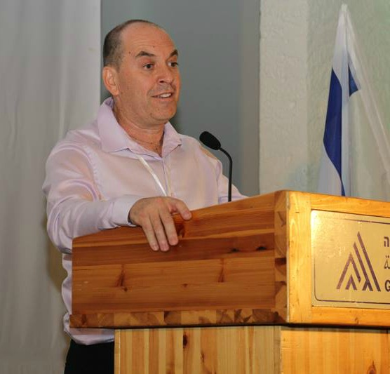
Yaniv Sagee
Executive Director,
The Center for Shared Society at Givat Haviva

Yaniv Sagee is the Executive Director of the Center for Shared Society at Givat Haviva since September of 2012. For over twenty years, Yaniv has been a key figure in various organizations connected to education in general, and youth movements in particular in Israel.

Yaniv is a native of Kibbutz Ein Hashofet where he is currently a member. After his initial army service, Yaniv became the shaliach for Hashomer Hatzair and Kibbutz Aliyah Desk in Chicago. Upon returning to Israel, he worked in Ein Hashofet’s dairy, before being asked to take the post of General Secretary of the kibbutz. At the age of 26, this made Yaniv the youngest kibbutz member to hold such a position in a veteran kibbutz.

After serving as General Secretary for two years, Yaniv worked from 1995-2000 at a local high school, first as a teacher and then as the boarding school principal. From 2000-2005, Yaniv became the head of Hashomer Hatzair, and then became the chairman of the National Council for Youth Movements in Israel for three years. From 2005-2009, he assumed the post of general secretary of Ein Hashofet for a second time. Yaniv then served as the Central Shaliach for the Givat Haviva Educational Foundation, the Hashomer Hatzair youth movement, and the Kibbutz Movement of North America.

During his extensive career, Yaniv also volunteered his expertise to such endeavors as – serving on the steering committee of the Partnership 2000 team of the local Megiddo Municipality; advising and directing decision making at Kibbutz Pelech, a young kibbutz in the Galilee; and leading the implementation of a project to renovate and preserve Jewish sites in Poland with the National Council for Youth Movements.

Yaniv’s experiences have facilitated extensive working collaborations with Ministers of Education, Department of Education Vice Chairmen, Knesset members, Mayors and Regional Council Members, Arab Municipal Leaders, Kibbutz Movement General Secretaries, and Directors of Partnership 2000.

Yaniv received his B.A. from Tel Aviv University in Jewish philosophy and General Studies which included education, Israeli history, and philosophy. Yaniv is married to Galia, a theatre director, teacher, and educational counselor, and they have three children together.

