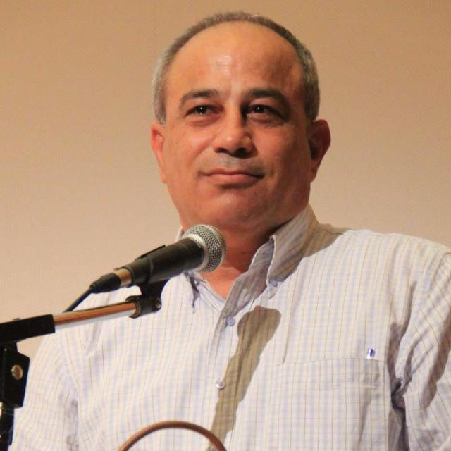Mohammad Darawshe

Director of Planning, Equality and Shared Society

The Center for Shared Society at Givat Haviva

Mohammad Darawshe is the Director of Planning, Equality and Shared Society at Givat Haviva, the Center for Shared Society in Israel. Mohammad is Arab with an Israeli passport — a Muslim Palestinian citizen of the State of Israel. Like 20 percent of Israel's population, he is, as he puts it, a child of both identities. He brings an unexpected way of seeing inside the Middle Eastern present and future. Previously, from 2005-2013 Mohammad served as the Co-Director of the Abraham Fund Initiatives. Before that he served as the Elections Campaign Manager for the Democratic Arab Party and later the United Arab List. Mohammad holds a B.A from the Hebrew University in Jerusalem, an M.A. in Public Administration from Hartford University, and an M.A. in Peace and Conflict Management from Haifa University. Mohammad is considered a leading expert on Jewish-Arab relations and has presented lectures and papers at the European parliament, NATO Defense College, the World Economic Forum, Club de Madrid, US Congress, the Herzlia Conference, and Israel's Presidential Conference.

Mohammad’s knowledge and expertise has been awarded several times, including the Peacemakers Award from the Catholic Theological Union, the Peace and Security Award from the World Association of NGOs, as well as the Leadership Fellow of the New Israel Fund. In 2008 he was elected as a council member in his hometown Iksal. In 2009 Mohammad served as a member of the National Committee, which drafted landmark Coexistence Education policy. Mohammad frequently appears on Arab Satellite TV news programs analyzing current Israeli political and social trends.

Mohammad is currently a member of:

The Three-Sector Roundtable at the Prime Minister's Office

Strategic Planning Team of the Authority for Economic Development of the Arab Sector
Executive Board of the One-Voice Movement
Public Council of Midot, Israel's NGO Rating Organization
Executive Board of Civil Leadership

